Create a Blanket Travel Request

- Log in to Concur

Travelers skip to #2

  - Delegates Only: Click Profile on the upper-right of your dashboard and begin typing the traveler’s name to search and select from the list field under Acting on behalf of another user:
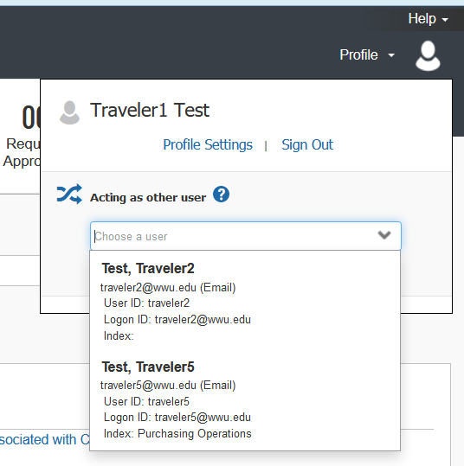
- If you do not have the Acting as other User option or the traveler’s name does not come up in the search, the traveler must assign you as a delegate in their Profile Settings, or email Travel.Services@wwu.edu to enable delegate permissions.
- Click Start Session. You are now acting as a delegate for this user, shown by the doubled profile icon and green label “Acting as (Traveler’s Name).”
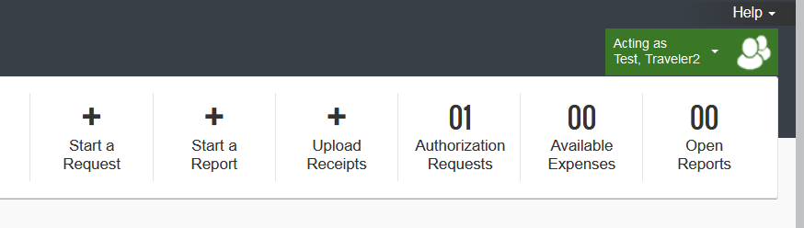

- Click +New, then Start a Request at top of screen.
- Complete all required header fields marked with a red asterisk:

- Trip Name: include date span authorized for travel; ex: “Blanket FY 24” or “Blanket Travel Fall Quarter 2024”
- Trip Start/End Dates: ex: 07/01/2023-06/30/2024. Max one year span.
- Trip Purpose: select Blanket Travel Request
- Main Destination City: choose most common travel destination. Limited to in-state travel.
- Travel Justification: clearly describe the business need for the travel. Ex: “Teaching weekend MBA classes at a satellite campus.” Include official workstation if not Bellingham. One-time events, such as conferences, require a separate Request.
- Enter or confirm funding. Start by typing in first few letters of the fast index (ex: FBBUYS). Split-fund (allocate) individual expenses on the next screen if needed.

Click the blue Create Request button.
- Add all anticipated expenses. Amounts should reflect estimates for the time span covered by the Blanket Request.
- Split or change funding for an expense: click Allocate, select the expense and Add New Allocation.
- Request Details menu: Review Request Timeline. If your approver(s) are incorrect, contact Travel.Services@wwu.edu to update.
- Click the orange Submit Request button (Delegates see Notify Employee button). Traveler and Delegates receive a notice when the Request is approved.
- Request Statuses: Not Submitted, Submitted and Pending Approval, Approved.
- Recall a Request if editing is needed by navigating to Requests tab, clicking on the document to open and selecting Recall under More Actions. May also Cancel and Close Requests if needed. Delete (only if unsubmitted) via trash can icon.

