ENTERPRISE/NATIONAL RENTAL CAR RESERVATION INSTRUCTIONS

Note: WWU’s contracted rates, including Enterprise, National and Hertz rentals, are also available to book via Concur Travel: How to Book Flights and more in Concur Travel

- Open Western’s Enterprise Reservation Portal (for business use only)
- Select Enterprise or National car rental
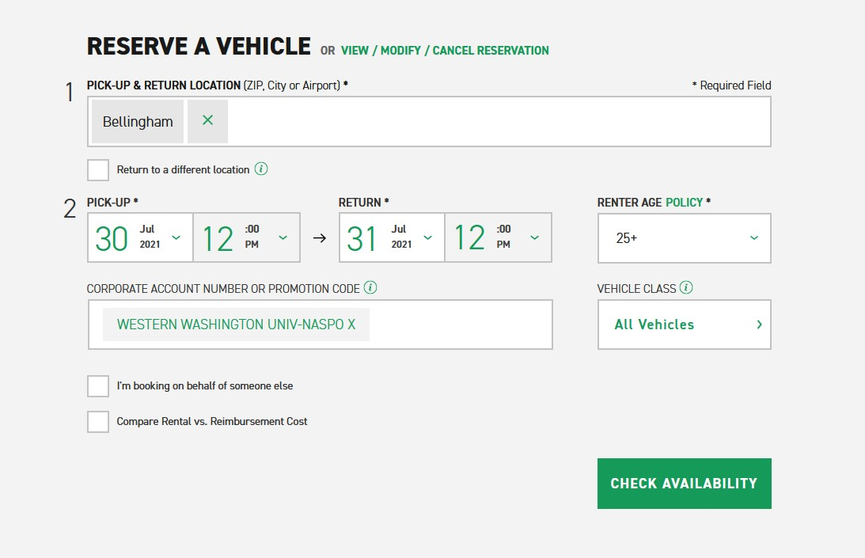
- Enter Reservation Details. The Corporate Account Western WA Univ-NASPO should display:
- Check the box "I'm booking on behalf of someone else" if applicable. Leave Emerald Club Member Number field blank.
- Search for and select a vehicle. Decline add-ons. Damage Waiver is included for domestic rentals. See WWU Risk Management: Transportation for required driver safety training. NOTE: WWU prohibits the use of all 15-passenger vans.
- Review & Reserve: enter Contact Details.

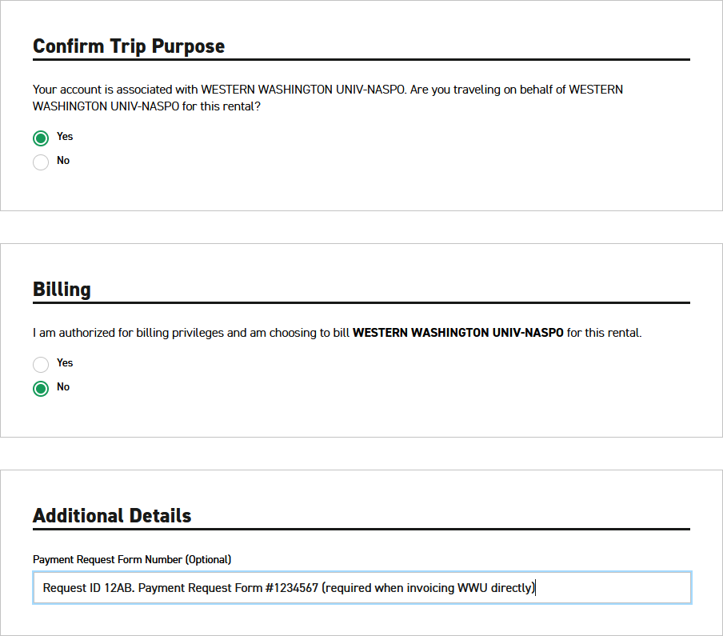

- Billing Option 1: Select No and the driver will need to present a payment card at time of pickup. Billing Option 2: Select Yes if using a department billing number and enter the number in the Billing Number field that opens below. Contact Travel Services for a billing number to invoice WWU directly for the rental*, or for steps to establish a department billing number connected to a PCard.
- Additional Details: Enter TA # or Request ID. *Only when invoicing WWU directly, first create a Payment Request for Vendors web form for the rental.
Complete Section 4 on the Payment Request form as shown below.
Request: Check Request
Vendor Name: Enterprise EAN SERVICES, LLC
Vendor Address: PO BOX 402383 ATLANTA, GA 30384-2383
W01210807
After entering the required information on the web form, SAVE and then copy the form # from the top of the form. Return to the Enterprise Reservation and enter the saved Payment Request Form Number in the Additional Details field. You will process the saved Payment Request web form after the rental is returned and closed, with final charges and invoice attached.
- Complete remaining reservation fields – it’s recommended to include Flight Details if applicable. Reserve Now and complete Reservation.

