How to Book Flights, Hotel, Rental cars and more in Concur Travel Booking Tool
The Concur Travel tab and Booking Tool is supported by Collegiate Travel Planners, Western's preferred travel agency. The Concur Travel tab is similar to booking sites like Expedia and Google Flights.
With the Concur Travel tab you can:
- Book your airfare, lodging, and rental car in one transaction
- Get contracted and discounted rates
- Earn miles and rewards
- Track unused airfare credits from canceled trips
- Book on the go with the Concur Mobile App
- Track your itinerary and link your accounts using TripIt Pro
Note: For more complex trips such as group trips, international travel, to change/cancel a trip or to use a flight credit, contact CTP directly: Click to Email an Agent﻿ / 888-315-2643

Book travel online only after the Concur Request (TA) has been approved.
- Login to Concur.
➢ Travelers skip to #2
➢ Delegates Only: Click Profile on the upper-right of your dashboard and begin typing the traveler’s name to search and select from the list field under Acting as other user:
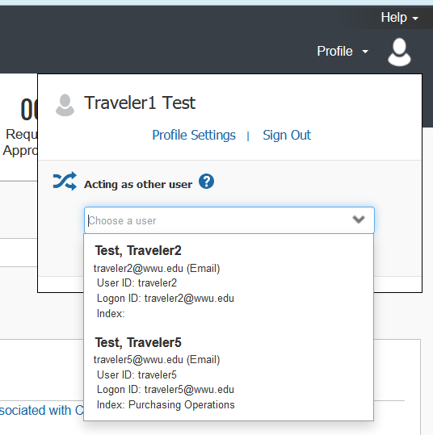

• If you do not have the Acting as other User option or the traveler’s name does not come up in the search, the traveler must assign you as a delegate in their Profile Settings. Travel Services can also enable delegate permissions.
• Click Start Session. You are now acting as a delegate for this user, shown by the green label “Acting as . . .”:
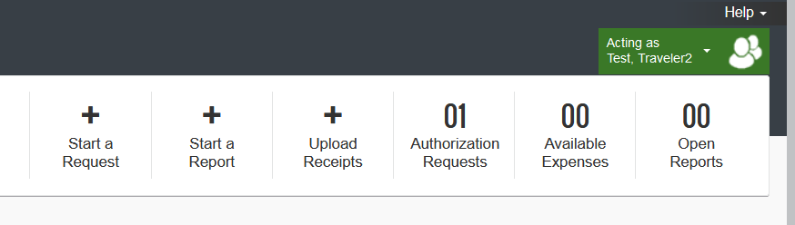
- Or, if booking on behalf of a guest (non-employee), such as a speaker or an interview candidate, select Book for a Guest. Contact Travel Services if needed and you do not see this option.

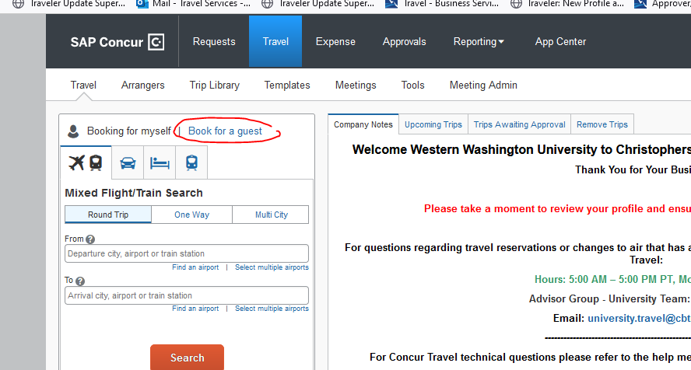
- Important: Confirm the traveler’s information is correct and complete before booking. Navigate to Profile > Profile Settings > Personal Information > Name and Airport Security: Please make certain that the first, middle, and last names are identical to those on the photo identification that the traveler will be presenting at the airport. Due to increased airport security, you may be turned away at the gate if the name on your identification does not match the name on your ticket.
- Click the Travel tab at the top of the dashboard:
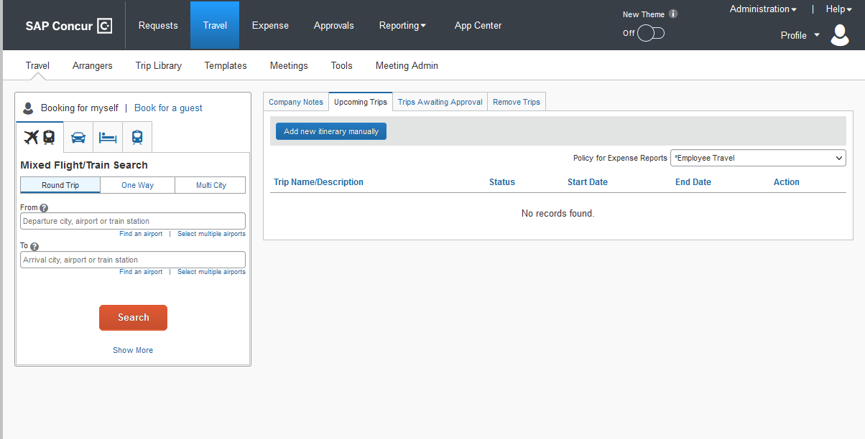

- Default search is for Flight/Train, round trip. Select One Way or Multi-City if applicable.
- Click in the Departure city field and start typing in location (BLI, SEA, Bellingham, etc.) Enter Arrival city, depart/return dates. NOTE: Use the Find an airport and Select multiple airports links as needed.
NOTE: Tick the boxes next to Pick-up/Drop-off car at airport and/or Find a Hotel if needing to book a rental car and/or hotel for the same trip to link reservations and limit agency fees:
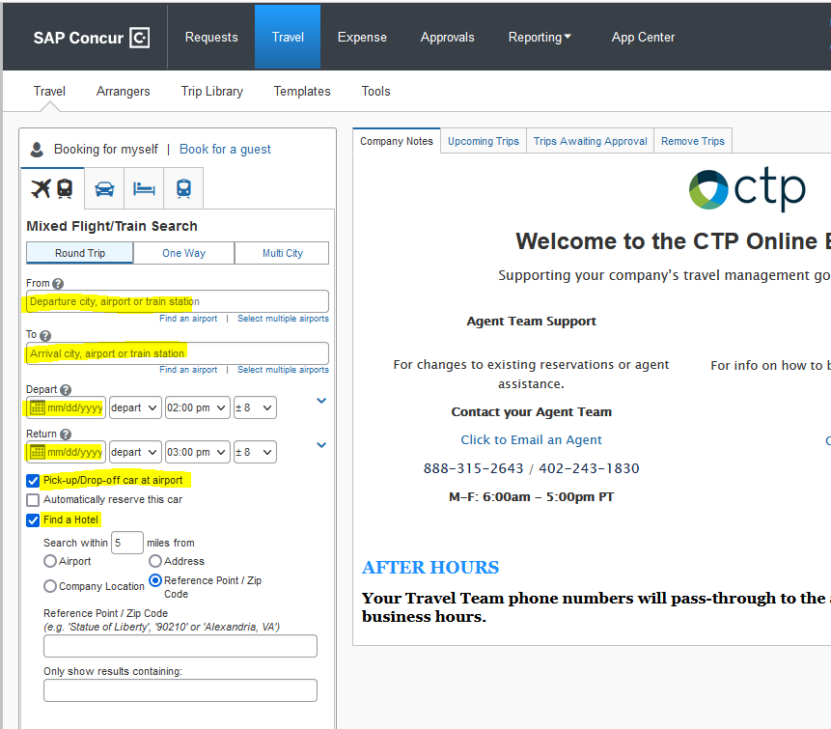

- Click the orange Search button to return results. Tabs allow user to view options by Fares or Schedule. Sort by price, duration, stops, emissions, etc.
- Flight schedules, layovers and travel times display. Select flight by clicking blue button on right. There may be multiple far options (View Fares). Select to advance to booking:

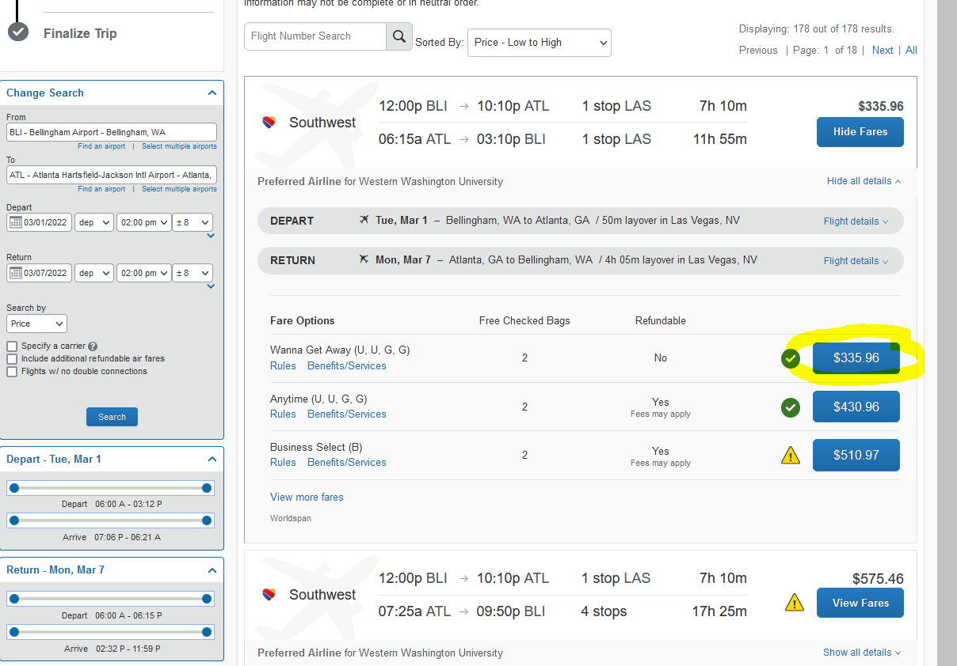
- Add or Select Frequent Flyer Program if applicable; select seats if option available.
- Select or enter credit card information to book (can work with department manager/admin to enter pcard if available or use your personal card to be reimbursed after the trip).
- Click Reserve Flight and Continue. Be sure to proceed through all the review and booking screens:
- 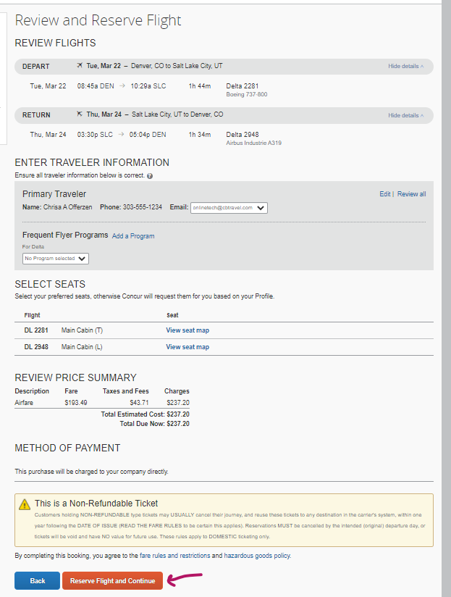
- Review Details and click Next at the bottom of the screen to finalize and confirm booking:
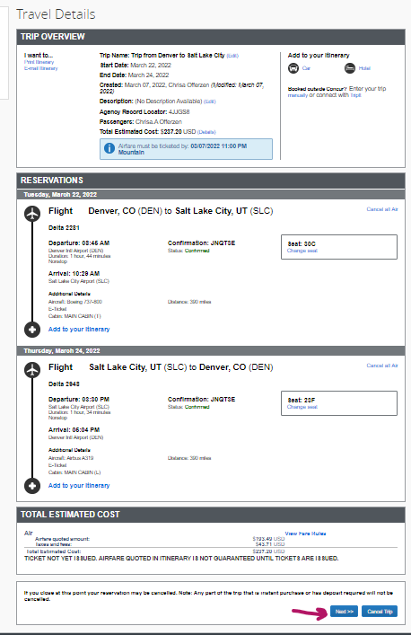
- Trip Confirmation Screen: Purchase Tickets. Final screen should display “Finished!” and Trip Overview.
- Upon successful ticketing, an itinerary confirmation will be emailed to the traveler and the arranger (Delegate)
- Note: To book special conference hotel negotiated rates, you may need to book outside Concur.

