Quick Reference: CMM Statuses
The contract status is shown on the CMM record header to the right of the ID.

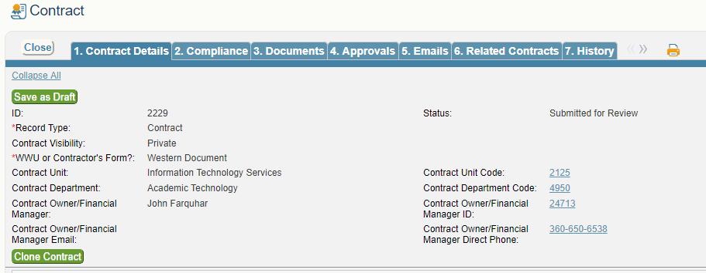

- Draft: Department has started the record, not yet submitted to CA for processing
- Submitted for Review: Department submitted. Pending CA receipt/action/review
- Internal Review: Status used for more extensive CA review.
- Pending Approval: Contract is undergoing department/risk/aag approval workflow.
- Approved Pending Signature: Approval workflow is complete. CA to review for revisions or redlines. Contract not yet sent for signature.
- Approved with Advisory Notes: CA is negotiating redlines.
- Submitted for Signature: Awaiting party signatures.
- Signed: Contract has been fully executed
- Active: Status changes from Signed to Active on the contract start date
- Active Pending Pmt Method Confirmation: Record needs payment method field completed (done by purchasing upon receipt of payment request)
- Renegotiating: Status used when revising an active agreement
- Cancelled: Contract was never signed/active but cancelled in processing
- Terminated: Active contract was terminated before contract end date
- Inactive: Contract end date has passed
- Amended: Contract has an active amendment
- Staged for Deletion: Record will be deleted pending CA confirmation. Usually due to a record created in error.

